**WNR PCB Assembly Instructions**

**Wireless Neural Recorder - Senior Design Team**

**Yuan Gao, Xin Huang, Tingkai Liu, Stephen Xia**

**Department of Electrical and Computer Engineering, Rice University**

**ricewnr@gmail.com**

The complete system of Wireless Neural Recorder has four main components: the neural electrode, the analog front-end board, the microprocessor board, and the battery board. The components are stacked on top of each other as described in Figure 1:

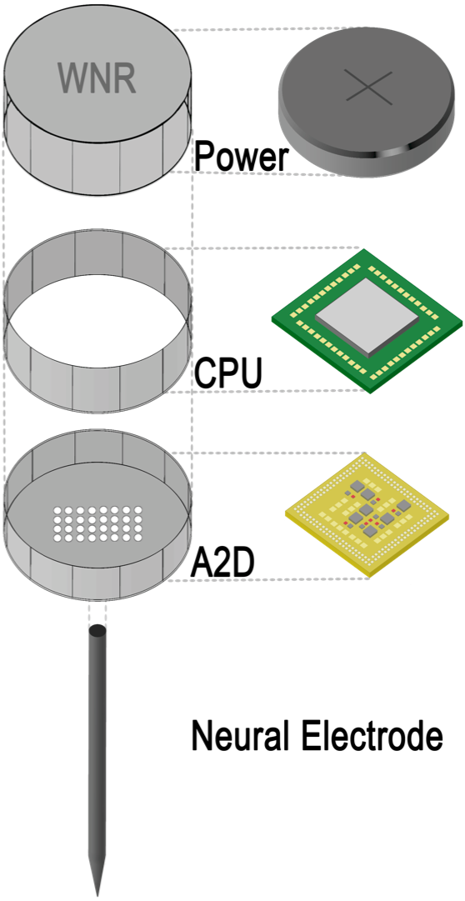

**Figure 1**

The entire assembly process must be performed in a clean, dry, and ventilated room.

**NEURAL ELECTRODE**

INTRODUCTION

The neural electrode is composed by two parts: the probe, and the sockets. The probe has a white cap on top, and a long, soft strip of stainless steel whose length varies with number of channels. The probe and the sockets are connected through thin wire, and the end-adapter contains through holes for sampling bus connection.

ASSEMBLY INSTRUCTIONS

Step 1: Cleanse the neural electrode. Carefully wipe the probe part, as well as the socket part. This is crucial to generate solid mounting points for the channels.

Step 2: Choose the right length of conducting wire between the probe and neural electrode. Since the original cap will be replaced, typically this portion of wire, together with the previous socket part, is removed.

Step 3: Carefully process the wires coming out from the probe. Arrange the terminals of the wires in the form of a matrix. Assume the typical type of neural electrode with 16 channels, arrange them into a four by four matrix.

**ANALOG FRONT-END**

INTRODUCTION

The analog front-end is a PCB with Intan 32 Channel A2D chip, which is shown in Figure 2:

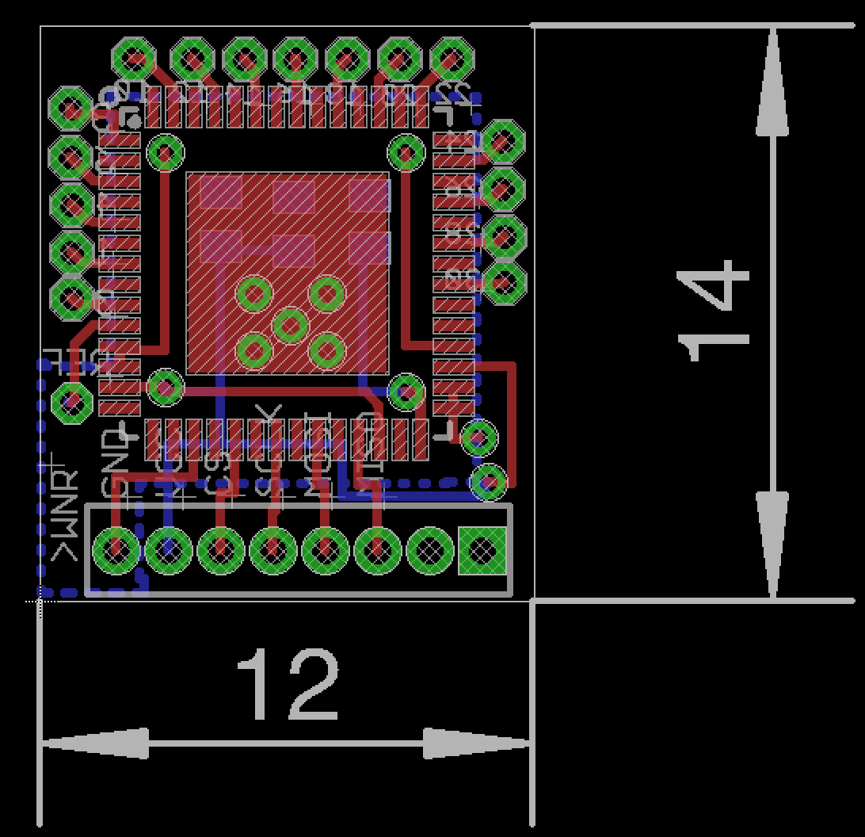

**Figure 2**

There are five main components on board: the Intan chip, two 100nF capacitors, one 10nF capacitor, and 8 header pins. This part functions as an interface between the neural electrode and on-board processing unit.

ASSEMBLY INSTRUCTIONS

Step 1: Carefully solder the components onto the micro-PCB. Make sure the entire process is conducted under ESD free environment, since Intan chip is extremely susceptible to such damage.

Step 2: Combine the previously assembled analog bus with Intan input pins. Thus the sampling channels are connected with the Intan board layer.

Step 3: Run end-to-end signal testings by applying voltage on each mounting point and read measurement from connected components. Examine each connected wires and pins, make sure parts are combined correctly together. Use microscope to check clearance, if necessary.

**MICROPROCESSOR BOARD**

INTRODUCTION

Microprocessor board is the core of the entire WNR device. The CPU is a Nordic nrf52 microprocessor, which reads in sampled digital signals from the Intan board below, processes and transmits the data. The board layout is displayed in Figure 3:

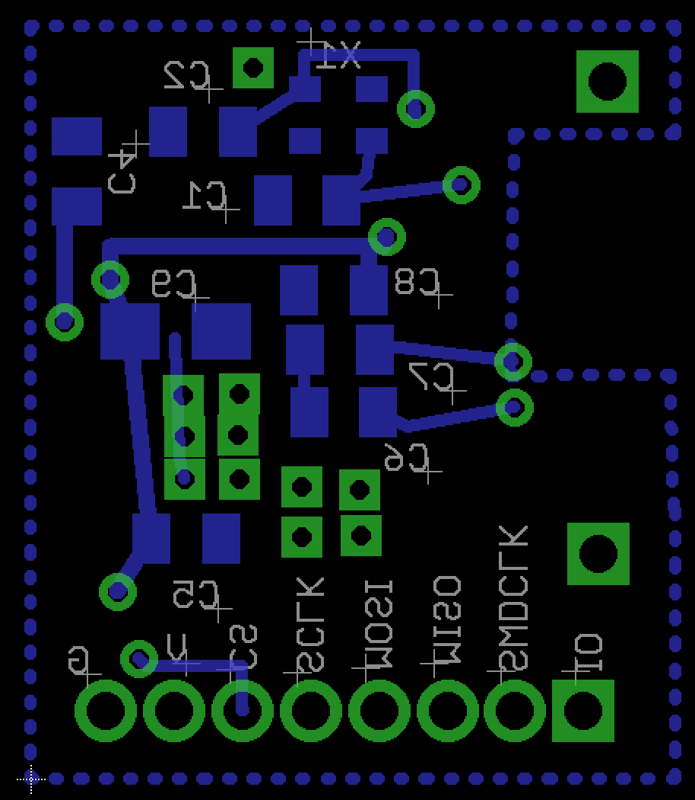

**Figure 3**

The main board is composed by high frequency chip inductors, capacitors, BLE antenna, and the nrf52 chip.

ASSEMBLY INSTRUCTIONS

Step 1: Carefully solder the components onto the micro-PCB.

Step 2: As shown in Figure 2 and Figure 3, calibrate the connecting vias and carefully solder them together. Thus the Intan front-end layer is connected with the processor unit.

Step 3: Run end-to-end signal testings by applying voltage on each mounting point and read measurement from connected components. Examine each connected wires and pins, make sure parts are combined correctly together. Use microscope to check clearance, if necessary.

**BATTERY BOARD**

INTRODUCTION

The battery board layer functions as the power unit for the entire system, as shown in Figure 4:

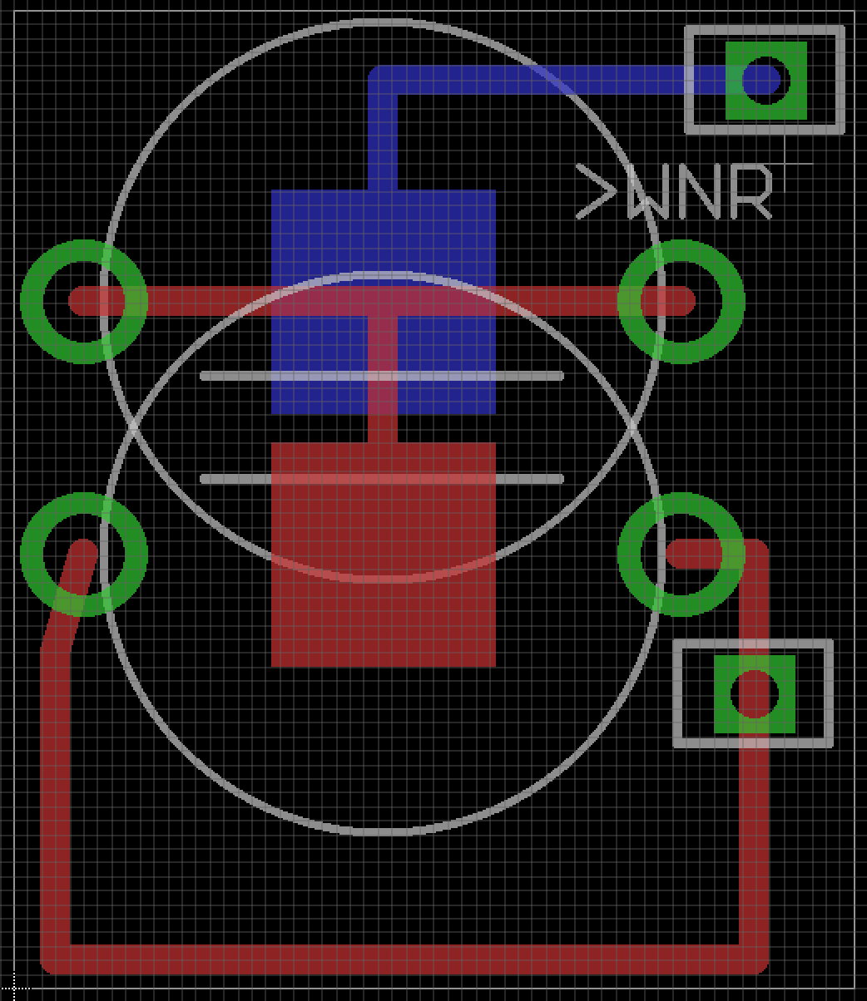

**Figure 4**

The battery board contains a 7.9mm battery holder, which holds the same dimension silver oxide battery to produce power for the layers below.

ASSEMBLY INSTRUCTIONS

Step 1: Carefully solder the components onto the micro-PCB board.

Step 2: The final assembly step. Calibrate the VDD and GND vias of the battery holder, and solder them with the processor unit layer below. Thus all four components are connected together.

Step 3: Run end-to-end signal testings by applying voltage on each mounting point and read measurement from connected components. Examine each connected wires and pins, make sure parts are combined correctly together. Use microscope to check clearance, if necessary.